1. **Create a Spring Web Project using Maven**

**Code:**

**SpringLearnApplication.java**

package com.cognizant.springlearn;

import org.springframework.boot.SpringApplication;

import org.springframework.boot.autoconfigure.SpringBootApplication;

@SpringBootApplication

public class SpringLearnApplication {

public static void main(String[] args) {

SpringApplication.run(SpringLearnApplication.class, args);

}

}

**application.properties**

server.port=8083

spring.application.name=spring-learn

**pom.xml**

<dependency>

<groupId>org.springframework.boot</groupId>

<artifactId>spring-boot-starter-web</artifactId>

</dependency>

**Output:**

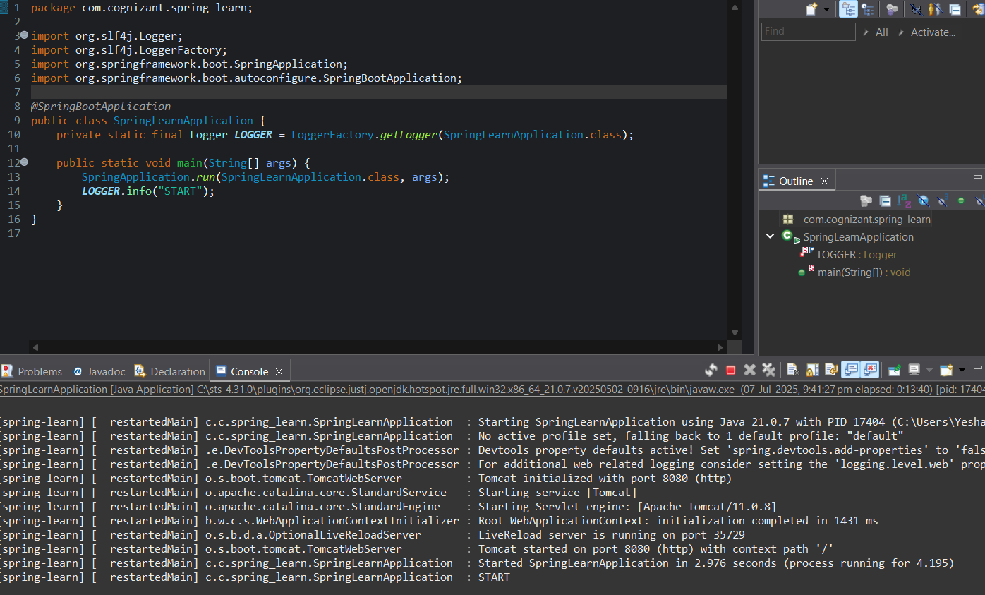

1. **Spring Core – Load Country from Spring Configuration XML**

**Code:**

**country.xml (located in src/main/resources)**

<?xml version="1.0" encoding="UTF-8"?>

<beans xmlns="http://www.springframework.org/schema/beans"

xmlns:xsi="http://www.w3.org/2001/XMLSchema-instance"

xsi:schemaLocation="http://www.springframework.org/schema/beans

https://www.springframework.org/schema/beans/spring-beans.xsd">

<bean id="country" class="com.cognizant.springlearn.Country">

<property name="code" value="IN" />

<property name="name" value="India" />

</bean>

</beans>

**Country.java (in com.cognizant.springlearn)**

package com.cognizant.springlearn;

import org.slf4j.Logger;

import org.slf4j.LoggerFactory;

public class Country {

private static final Logger LOGGER = LoggerFactory.getLogger(Country.class);

private String code;

private String name;

public Country() {

LOGGER.debug("Inside Country Constructor.");

}

public String getCode() {

LOGGER.debug("Getting country code");

return code;

}

public void setCode(String code) {

LOGGER.debug("Setting country code: {}", code);

this.code = code;

}

public String getName() {

LOGGER.debug("Getting country name");

return name;

}

public void setName(String name) {

LOGGER.debug("Setting country name: {}", name);

this.name = name;

}

@Override

public String toString() {

return "Country{" +

"code='" + code + '\'' +

", name='" + name + '\'' +

'}';

}

}

**SpringLearnApplication.java (Main class)**

package com.cognizant.springlearn;

import org.slf4j.Logger;

import org.slf4j.LoggerFactory;

import org.springframework.context.ApplicationContext;

import org.springframework.context.support.ClassPathXmlApplicationContext;

public class SpringLearnApplication {

private static final Logger LOGGER = LoggerFactory.getLogger(SpringLearnApplication.class);

public static void main(String[] args) {

displayCountry();

}

public static void displayCountry() {

ApplicationContext context = new ClassPathXmlApplicationContext("country.xml");

Country country = (Country) context.getBean("country", Country.class);

LOGGER.debug("Country : {}", country.toString());

}

}

**pom.xml Dependencies**

<dependency>

<groupId>org.springframework</groupId>

<artifactId>spring-context</artifactId>

<version>5.3.34</version>

</dependency>

<dependency>

<groupId>org.slf4j</groupId>

<artifactId>slf4j-api</artifactId>

<version>1.7.36</version>

</dependency>

<dependency>

<groupId>org.slf4j</groupId>

<artifactId>slf4j-simple</artifactId>

<version>1.7.36</version>

</dependency>

**Output:**

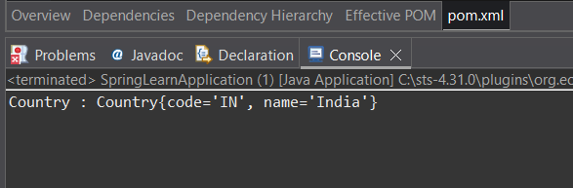

1. **Hello World RESTful Web Service**

**Code:**

**country.xml**

<?xml version="1.0" encoding="UTF-8"?>

<beans xmlns="http://www.springframework.org/schema/beans"

xmlns:xsi="http://www.w3.org/2001/XMLSchema-instance"

xsi:schemaLocation="

http://www.springframework.org/schema/beans

https://www.springframework.org/schema/beans/spring-beans.xsd">

<bean id="country" class="com.cognizant.springlearn.Country">

<property name="code" value="IN"/>

<property name="name" value="India"/>

</bean>

</beans>

**Country.java (in com.cognizant.springlearn)**

package com.cognizant.springlearn;

import org.slf4j.Logger;

import org.slf4j.LoggerFactory;

public class Country {

private static final Logger LOGGER = LoggerFactory.getLogger(Country.class);

private String code;

private String name;

public Country() {

LOGGER.debug("Inside Country Constructor.");

}

public String getCode() {

LOGGER.debug("Getting country code");

return code;

}

public void setCode(String code) {

LOGGER.debug("Setting country code: {}", code);

this.code = code;

}

public String getName() {

LOGGER.debug("Getting country name");

return name;

}

public void setName(String name) {

LOGGER.debug("Setting country name: {}", name);

this.name = name;

}

@Override

public String toString() {

return "Country{" +

"code='" + code + '\'' +

", name='" + name + '\'' +

'}';

}

}

**SpringLearnApplication.java**

package com.cognizant.springlearn;

import org.slf4j.Logger;

import org.slf4j.LoggerFactory;

import org.springframework.context.ApplicationContext;

import org.springframework.context.support.ClassPathXmlApplicationContext;

public class SpringLearnApplication {

private static final Logger LOGGER = LoggerFactory.getLogger(SpringLearnApplication.class);

public static void main(String[] args) {

displayCountry();

}

public static void displayCountry() {

ApplicationContext context = new ClassPathXmlApplicationContext("country.xml");

Country country = context.getBean("country", Country.class);

LOGGER.debug("Country : {}", country.toString());

}

}

**pom.xml Dependencies**

<!-- Spring Core Context -->

<dependency>

<groupId>org.springframework</groupId>

<artifactId>spring-context</artifactId>

<version>5.3.34</version>

</dependency>

<!-- SLF4J Logging -->

<dependency>

<groupId>org.slf4j</groupId>

<artifactId>slf4j-api</artifactId>

<version>1.7.36</version>

</dependency>

<dependency>

<groupId>org.slf4j</groupId>

<artifactId>slf4j-simple</artifactId>

<version>1.7.36</version>

</dependency>

**Output:**

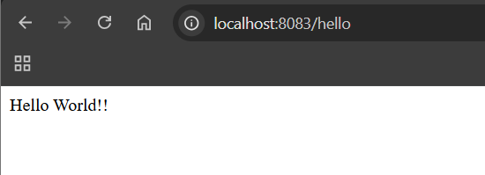

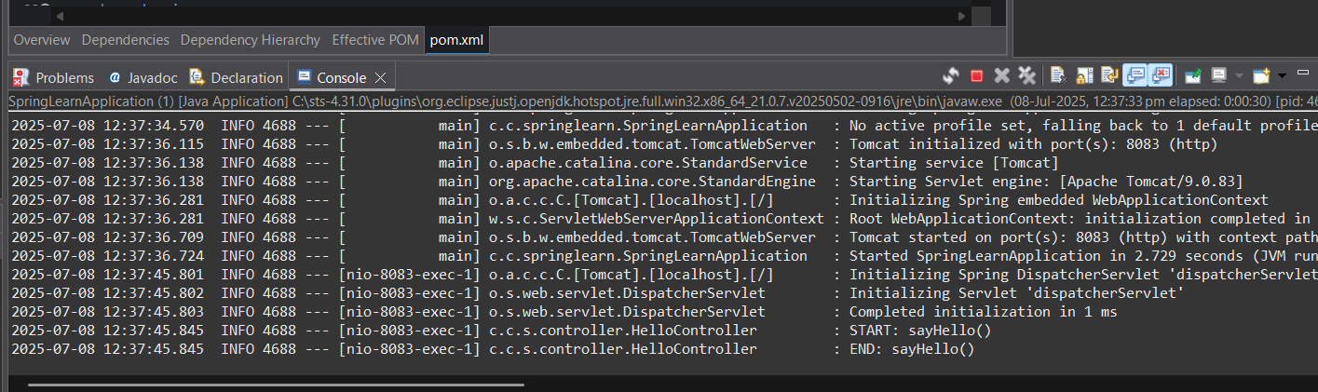

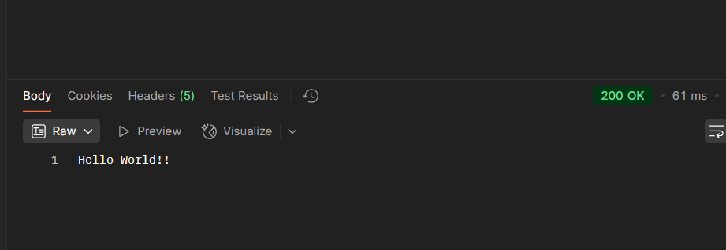

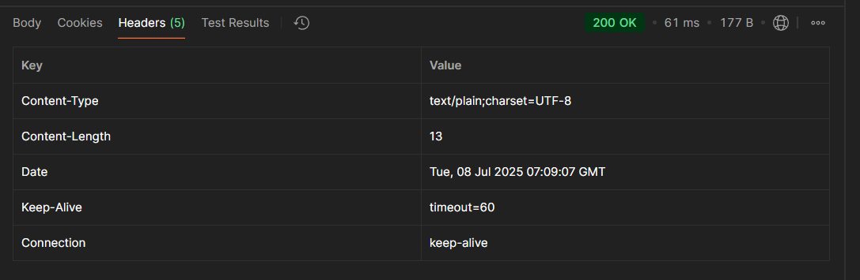

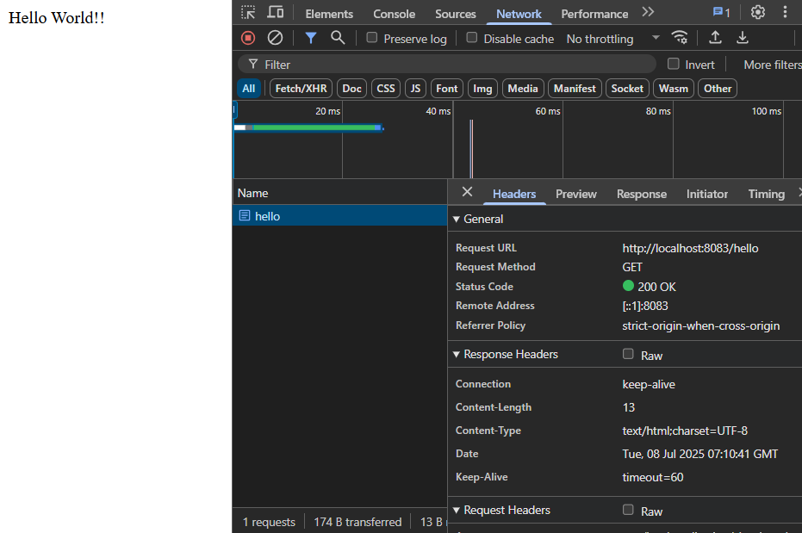

1. **REST - Country Web Service**

**Code:**

**country.xml**

<?xml version="1.0" encoding="UTF-8"?>

<beans xmlns="http://www.springframework.org/schema/beans"

xmlns:xsi="http://www.w3.org/2001/XMLSchema-instance"

xsi:schemaLocation="http://www.springframework.org/schema/beans

https://www.springframework.org/schema/beans/spring-beans.xsd">

<bean id="country" class="com.cognizant.springlearn.Country">

<property name="code" value="IN"/>

<property name="name" value="India"/>

</bean>

</beans>

**Country Class**

package com.cognizant.springlearn;

public class Country {

private String code;

private String name;

public Country() {}

public String getCode() {

return code;

}

public void setCode(String code) {

this.code = code;

}

public String getName() {

return name;

}

public void setName(String name) {

this.name = name;

}

@Override

public String toString() {

return "Country{" + "code='" + code + '\'' + ", name='" + name + '\'' + '}';

}

}

**CountryController.java**

package com.cognizant.springlearn.controller;

import com.cognizant.springlearn.Country;

import org.slf4j.Logger;

import org.slf4j.LoggerFactory;

import org.springframework.context.ApplicationContext;

import org.springframework.context.support.ClassPathXmlApplicationContext;

import org.springframework.web.bind.annotation.RequestMapping;

import org.springframework.web.bind.annotation.RestController;

@RestController

public class CountryController {

private static final Logger LOGGER = LoggerFactory.getLogger(CountryController.class);

@RequestMapping("/country")

public Country getCountryIndia() {

LOGGER.info("START: getCountryIndia()");

ApplicationContext context = new ClassPathXmlApplicationContext("country.xml");

Country country = context.getBean("country", Country.class);

LOGGER.info("END: getCountryIndia()");

return country;

}

}

**SpringLearnApplication.java (Main Class)**

package com.cognizant.springlearn;

import org.springframework.boot.SpringApplication;

import org.springframework.boot.autoconfigure.SpringBootApplication;

@SpringBootApplication

public class SpringLearnApplication {

public static void main(String[] args) {

SpringApplication.run(SpringLearnApplication.class, args);

}

}

**application.properties**

server.port=8083

**Output:**

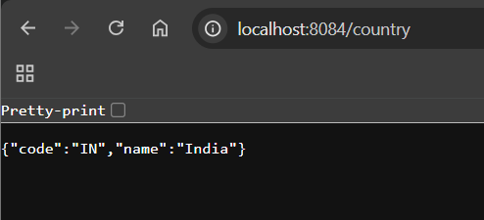

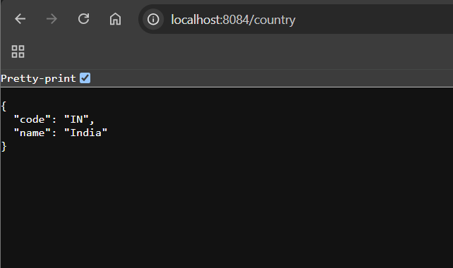

1. **REST - Get country based on country code**

**Code:**

**country.xml**

<?xml version="1.0" encoding="UTF-8"?>

<beans xmlns="http://www.springframework.org/schema/beans"

xmlns:xsi="http://www.w3.org/2001/XMLSchema-instance"

xsi:schemaLocation="http://www.springframework.org/schema/beans

https://www.springframework.org/schema/beans/spring-beans.xsd">

<bean id="country" class="com.cognizant.springlearn.Country">

<property name="code" value="IN"/>

<property name="name" value="India"/>

</bean>

<bean id="countryList" class="java.util.ArrayList">

<constructor-arg>

<list>

<bean class="com.cognizant.springlearn.Country">

<property name="code" value="IN"/>

<property name="name" value="India"/>

</bean>

<bean class="com.cognizant.springlearn.Country">

<property name="code" value="US"/>

<property name="name" value="United States"/>

</bean>

<bean class="com.cognizant.springlearn.Country">

<property name="code" value="DE"/>

<property name="name" value="Germany"/>

</bean>

<bean class="com.cognizant.springlearn.Country">

<property name="code" value="JP"/>

<property name="name" value="Japan"/>

</bean>

</list>

</constructor-arg>

</bean>

</beans>

**CountryService.java**

package com.cognizant.springlearn.service;

import com.cognizant.springlearn.Country;

import org.springframework.context.ApplicationContext;

import org.springframework.context.support.ClassPathXmlApplicationContext;

import org.springframework.stereotype.Service;

import java.util.List;

@Service

public class CountryService {

public Country getCountry(String code) {

ApplicationContext context = new ClassPathXmlApplicationContext("country.xml");

List<Country> countries = (List<Country>) context.getBean("countryList");

// Case-insensitive search

return countries.stream()

.filter(country -> country.getCode().equalsIgnoreCase(code))

.findFirst()

.orElse(null);

}

}

**CountryController.java**

package com.cognizant.springlearn.controller;

import com.cognizant.springlearn.Country;

import com.cognizant.springlearn.service.CountryService;

import org.springframework.beans.factory.annotation.Autowired;

import org.springframework.web.bind.annotation.*;

@RestController

public class CountryController {

@Autowired

private CountryService countryService;

@RequestMapping("/country")

public Country getCountryIndia() {

ApplicationContext context = new ClassPathXmlApplicationContext("country.xml");

return context.getBean("country", Country.class);

}

@GetMapping("/countries/{code}")

public Country getCountry(@PathVariable String code) {

return countryService.getCountry(code);

}

}

**application.properties**

server.port=8083

spring.jackson.serialization.indent_output=true

**Output:**

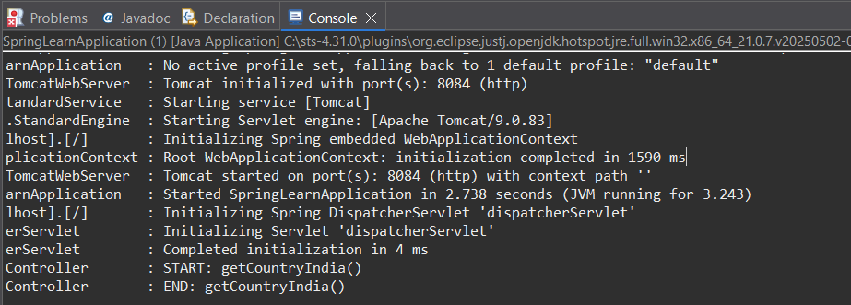



1. **Create authentication service that returns JWT**

**Code:**

**JwtAuthServiceApplication.java**

package com.example.jwtauthservice;

import org.springframework.boot.SpringApplication;

import org.springframework.boot.autoconfigure.SpringBootApplication;

@SpringBootApplication

public class JwtAuthServiceApplication {

public static void main(String[] args) {

SpringApplication.run(JwtAuthServiceApplication.class, args);

}

}

**JwtAuthenticationController.java**

package com.example.jwtauthservice.controller;

import com.example.jwtauthservice.model.JwtRequest;

import com.example.jwtauthservice.model.JwtResponse;

import com.example.jwtauthservice.service.CustomUserDetailsService;

import com.example.jwtauthservice.util.JwtUtil;

import org.springframework.beans.factory.annotation.Autowired;

import org.springframework.security.authentication.AuthenticationManager;

import org.springframework.security.authentication.UsernamePasswordAuthenticationToken;

import org.springframework.security.core.userdetails.UserDetails;

import org.springframework.web.bind.annotation.*;

@RestController

@CrossOrigin

public class JwtAuthenticationController {

@Autowired

private AuthenticationManager authenticationManager;

@Autowired

private CustomUserDetailsService userDetailsService;

@Autowired

private JwtUtil jwtUtil;

@PostMapping("/authenticate")

public JwtResponse createAuthenticationToken(@RequestBody JwtRequest jwtRequest) throws Exception {

authenticationManager.authenticate(

new UsernamePasswordAuthenticationToken(jwtRequest.getUsername(), jwtRequest.getPassword())

);

final UserDetails userDetails = userDetailsService.loadUserByUsername(jwtRequest.getUsername());

final String token = jwtUtil.generateToken(userDetails);

return new JwtResponse(token);

}

}

**JwtUtil.java**

package com.example.jwtauthservice.util;

import java.util.Date;

import java.util.HashMap;

import java.util.Map;

import java.util.function.Function;

import org.springframework.security.core.userdetails.UserDetails;

import org.springframework.stereotype.Component;

import io.jsonwebtoken.*;

@Component

public class JwtUtil {

private String SECRET_KEY = "secret";

public String extractUsername(String token) {

return extractClaim(token, Claims::getSubject);

}

public Date extractExpiration(String token) {

return extractClaim(token, Claims::getExpiration);

}

public <T> T extractClaim(String token, Function<Claims, T> claimsResolver) {

final Claims claims = extractAllClaims(token);

return claimsResolver.apply(claims);

}

private Claims extractAllClaims(String token) {

return Jwts.parser().setSigningKey(SECRET_KEY).parseClaimsJws(token).getBody();

}

private Boolean isTokenExpired(String token) {

return extractExpiration(token).before(new Date());

}

public String generateToken(UserDetails userDetails) {

Map<String, Object> claims = new HashMap<>();

return createToken(claims, userDetails.getUsername());

}

private String createToken(Map<String, Object> claims, String subject) {

return Jwts.builder()

.setClaims(claims)

.setSubject(subject)

.setIssuedAt(new Date(System.currentTimeMillis()))

.setExpiration(new Date(System.currentTimeMillis() + 1000 * 60 * 60 * 10)) // 10 hrs

.signWith(SignatureAlgorithm.HS256, SECRET_KEY)

.compact();

}

public Boolean validateToken(String token, UserDetails userDetails) {

final String username = extractUsername(token);

return (username.equals(userDetails.getUsername()) && !isTokenExpired(token));

}

}

**SecurityConfig.java**

package com.example.jwtauthservice.config;

import com.example.jwtauthservice.service.CustomUserDetailsService;

import org.springframework.context.annotation.Bean;

import org.springframework.context.annotation.Configuration;

import org.springframework.security.authentication.AuthenticationManager;

import org.springframework.security.config.annotation.authentication.configuration.AuthenticationConfiguration;

import org.springframework.security.config.annotation.web.builders.HttpSecurity;

import org.springframework.security.crypto.bcrypt.BCryptPasswordEncoder;

import org.springframework.security.crypto.password.PasswordEncoder;

import org.springframework.security.web.SecurityFilterChain;

@Configuration

public class SecurityConfig {

private final CustomUserDetailsService userDetailsService;

public SecurityConfig(CustomUserDetailsService userDetailsService) {

this.userDetailsService = userDetailsService;

}

@Bean

public AuthenticationManager authenticationManager(AuthenticationConfiguration config) throws Exception {

return config.getAuthenticationManager();

}

@Bean

public SecurityFilterChain filterChain(HttpSecurity http) throws Exception {

http.csrf(csrf -> csrf.disable())

.authorizeHttpRequests(auth -> auth

.requestMatchers("/authenticate").permitAll()

.anyRequest().authenticated()

);

return http.build();

}

@Bean

public PasswordEncoder passwordEncoder() {

return new BCryptPasswordEncoder();

}

}

**pom.xml**

<project xmlns="http://maven.apache.org/POM/4.0.0"

xmlns:xsi="http://www.w3.org/2001/XMLSchema-instance"

xsi:schemaLocation="http://maven.apache.org/POM/4.0.0

http://maven.apache.org/xsd/maven-4.0.0.xsd">

<modelVersion>4.0.0</modelVersion>

<groupId>com.example</groupId>

<artifactId>jwt-auth-service</artifactId>

<version>0.0.1-SNAPSHOT</version>

<packaging>jar</packaging>

<name>jwt-auth-service</name>

<properties>

<java.version>21</java.version>

<spring.boot.version>3.2.4</spring.boot.version>

</properties>

<dependencies>

<!-- Spring Boot Starter Web -->

<dependency>

<groupId>org.springframework.boot</groupId>

<artifactId>spring-boot-starter-web</artifactId>

</dependency>

<!-- Spring Boot Starter Security -->

<dependency>

<groupId>org.springframework.boot</groupId>

<artifactId>spring-boot-starter-security</artifactId>

</dependency>

<!-- JWT -->

<dependency>

<groupId>io.jsonwebtoken</groupId>

<artifactId>jjwt</artifactId>

<version>0.9.1</version>

</dependency>

<!-- Spring Boot Starter Test -->

<dependency>

<groupId>org.springframework.boot</groupId>

<artifactId>spring-boot-starter-test</artifactId>

<scope>test</scope>

</dependency>

</dependencies>

<build>

<plugins>

<!-- Spring Boot Maven Plugin -->

<plugin>

<groupId>org.springframework.boot</groupId>

<artifactId>spring-boot-maven-plugin</artifactId>

</plugin>

</plugins>

</build>

</project>

**Output:**

